A

Mini Project

On

**SOCIAL MEDIA AND MISLEADING INFORMATION IN A DEMOCRACY A MECHANISM DESIGN APPROACH**

(Submitted in partial fulfillment of the requirements for the award of Degree)

BACHELOR OF TECHNOLOGY

In

COMPUTER SCIENCE AND ENGINEERING

By

C.HEMA BINDU (207R1A05D4)

K.TEJA (207R1A05E7)

CH.NAVATEJ (207R1A05D2)

Under the Guidance of

#### K.SHILPA

(Assistant Professor)



#### CMR TECHNICAL CAMPUS

UGC AUTONOMOUS

(Accredited by NAAC, NBA, Permanently Affiliated to JNTUH, Approved by AICTE, New

Delhi) Recognized Under Section 2(f) & 12(B) of the UGCAct.1956, Kandlakoya (V), Medchal Road, Hyderabad-501401.

**2020-2024**

**DEPARTMENT OF COMPUTER SCIENCE AND ENGINEERING**



### CERTIFICATE

This is to certify that the project entitled **“SOCIAL MEDIA AND MISLEADING INFORMATION IN A DEMOCRACY A MECHANISM DESIGN APPROACH”** being submitted by **C.HEMA BINDU(207R1A05D4), K.TEJA(207R1A05E7) & CH.NAVATEJ(207R1A05D2)** in partial fulfillment of the requirements for the award of the degree of B.Tech in Computer Science and Engineering to the Jawaharlal Nehru Technological University Hyderabad, is a record of bonafide work carried out by them under our guidance and supervision during the year 2022-23.

The results embodied in this thesis have not been submitted to any other University or Institute for the award of any degree or diploma.

**K.Shilpa Dr. A. Raji Reddy**

(Assistant Professor) DIRECTOR

INTERNAL GUIDE

##### Dr. K. Srujan Raju EXTERNAL EXAMINER

HOD

**Submitted for viva Examination held on**

**ACKNOWLEDGEMENT**

Apart from the efforts of us, the success of any project depends largely on the encouragement and guidelines of many others. We take this opportunity to express our gratitude to the people who have been instrumental in the successful completion of this project.

We take this opportunity to express my profound gratitude and deep regard to my guide **k.Shilpa,** Assistant Professor for her exemplary guidance, monitoring and constant encouragement throughout the project work. The blessing, help and guidance given by him shall carry us a long way in the journey of life on which we are about to embark.

We also take this opportunity to express a deep sense of gratitude to the Project Review Committee (PRC)  **Ms. Shilpa** for their cordial support, valuable information and guidance, which helped us in completing this task through various stages.

We are also thankful to **Dr. K. Srujan Raju,** Head, Department of Computer Science and Engineering for providing encouragement and support for completing this project successfully.

We are obliged to **Dr. A. Raji Reddy,** Director for being cooperative throughout the course of this project. We also express our sincere gratitude to Sri. **Ch. Gopal Reddy,** Chairman for providing excellent infrastructure and a nice atmosphere throughout the course of this project.

The guidance and support received from all the members of **CMR Technical Campus** who contributed to the completion of the project. We are grateful for their constant support and help.

Finally, we would like to take this opportunity to thank our family for their constant encouragement, without which this assignment would not be completed. We sincerely acknowledge and thank all those who gave support directly and indirectly in the completion of this project.

##### C.HEMA BINDU (207R1A05D4)

**K.TEJA (207R1A05E7)**

**CH.NAVATEJ (207R1A05D2)**

#### ABSTRACT

We present a resource allocation mechanism for the study of the strategic behavior of social media interacting with citizens that form opinions in a democracy. In a world of information and the internet, it becomes imperative for social media to filter misleading opinions on their platforms. As this is too altruistic to expect from different social media to self-enforce, we propose a mechanism design formulation that provides appropriate monetary incentives to social media leading to an efficient filter-wide system outcome. Our proposed mechanism incentivizes strategic social media to efficiently filter misleading information and thus indirectly prevent the ever-emergent phenomenon of fake news. In particular, we consider an economically inspired mechanism that designs an implementable Nash equilibrium of efficient filtering of misleading information in a game of selfish social media platforms. We also show that our mechanism is individual rational and budget balance, two key characteristics of a democratic society.

Mechanism design was developed for the implementation of system-wide optimal solutions to problems involving multiple rational players with conflicting interests, each with private information about preferences . Note that this approach is different from traditional approaches to decentralized control with private information because the players are not a part of the same time, but in fact, have private and competitive utilities. The fact that Mechanism design optimizes the behaviour of competing players has led to broad applications spanning different fields including economics, politics, wireless networks, social networks, internet advertising, spectrum and bandwidth trading, logistics, supply chain, management, grid computing, and resource allocation problems in decentralized systems.

# LIST OF FIGURES

**FIGURE NO FIGURE NAME PAGE NO**

|  |  |  |
| --- | --- | --- |
| Figure 4.1 | Project Architecture | 16 |
| Figure 4.3 | Use Case Diagram | 17 |
| Figure 4.4 | Class Diagram | 18 |
| Figure 4.5 | Sequence Diagram | 19 |
| Figure 4.6 | Activity Diagram | 20 |

# LIST OF SCREENSHOTS

**SCREENSHOT NO. SCREENSHOT NAME PAGE NO**

Figure 6.1 Dataset 31

Figure 6.2 Disease names 31

Figure 6.3 run.bat 32

Figure 6.4 Upload Arrhythmia Dataset 32

Figure 6.5 Click open 33

Figure 6.6 Preprocess Dataset 33

Figure 6.7 Run LSTM Algorithm 34

Figure 6.8 Run CNN Algorithm 34

Figure 6.9 LSTM & CNN Training Graph 35

Figure 6.10 Performance Table 35

TABLE OF CONTENTS

**ABSTRACT** i

**LIST OF FIGURES** ii

**LIST OF SCREENSHOTS** iii

1. **INTRODUCTION** 1
   1. PROJECT SCOPE 2
   2. PROJECT PURPOSE 2
   3. PROJECT FEATURES 2

2. SYSTEM ANALYSIS 3

3.1 PROBLEM DEFINITION 4

3.2 EXISTING SYSTEM 10

3.2.1 DISADVANTAGES OF EXISTING SYSTEM 10

3.3 PROPOSED SYSTEM 11

3.3.1 ADVANTAGES OF PROPOSED SYSTEM 12

3.4 FEASIBILITY STUDY 13

3.4.1 ECONOMIC FEASIBILITY 13

3.4.2 TECHNICAL FEASIBILITY 13

3.4.3 SOCIAL FEASIBILITY 13

3.5 HARDWARE & SOFTWARE REQUIREMENTS 14

3.5.1 HARDWARE REQUIREMENTS 14

3.5.2 SOFTWARE REQUIREMENTS 14

1. ARCHITECTURE 15
   1. PROJECT ARCHITECTURE 16
   2. DESCRIPTION 16
   3. USE CASE DIAGRAM 17
   4. CLASS DIAGRAM 18
   5. SEQUENCE DIAGRAM 19
   6. ACTIVITY DIAGRAM 20
2. IMPLEMENTATION 21
   1. SAMPLE CODE 22
3. RESULTS 30
4. TESTING 36
   1. INTRODUCTION TO TESTING 37
      1. SOFTWARE TESTING 37
   2. TYPES OF TESTING 37
      1. UNIT TESTING 37
      2. INTEGRATION TESTING 38
      3. FUNCTIONAL TESTING 38

|  |  |
| --- | --- |
| 7.3 TEST CASES | 39 |
| 1. **CONCLUSION & FUTURE SCOPE**    1. PROJECT CONCLUSION    2. FUTURE SCOPE 2. **BIBLIOGRAPHY**    1. REFERENCES    2. GITHUB LINK | 41  42  43  44  45  47 |

# INTRODUCTION

### INTRODUCTION

#### 1.1 PROJECT SCOPE

The scope of the “Social Media and Misleading Information in a Democracy A Mechanism Design Approach” project encompasses the development of a robust and accurate decision making system. The primary aim is to create an intelligent model capable of identifying weather the news given is true or false related to the democracy of the country. This project would require interdisciplinary collaboration among researchers, data scientists, social media experts, policymakers, and stakeholders to address the complex challenges posed by misleading information on social media in the context of a democracy. The ultimate goal is to strengthen democratic processes and ensure the responsible use of social media platforms. The project will start with the collection of a diverse and representative dataset of misleading information, including both true news and fake news. Data pre-processing will involve removing stop words and all the unwanted data is removed and splitting it into training data and testing data.

#### 1.2 PROJECT PURPOSE

The purpose of the “Social Media and Misleading Information in a Democracy A Mechanism Design Approach” is to investigate, analyze, and address the pervasive issue of misleading information on social media platforms and its profound implications for democratic processes. By employing principles of mechanism design, the project aims to develop innovative strategies, policies, and interventions that can mitigate the spread of misinformation while preserving democratic values, fostering informed civic participation, and enhancing the integrity of public discourse in the digital age. Through rigorous research, modeling, stakeholder collaboration, and ethical considerations, this project seeks to contribute to the advancement of responsible information sharing and the protection of democratic institutions. The objective of this project is to explore the impact of media on the dissemination of misleading information, within a system using a mechanism design approach.

#### 1.3 PROJECT FEATURES

The project "Social Media and Misleading Information in a Democracy: A Mechanism Design Approach" incorporates several key features to comprehensively address the complex issue of misleading information in the context of democracy:

**Data-Driven Analysis:** It utilizes extensive data collection and analysis from social media platforms to gain insights into the dissemination patterns and impact of misinformation, enabling evidence-based decision-making.

**Public Awareness and Education:** The project emphasizes the importance of educating the public to recognize and resist misinformation, leading to greater resilience against deceptive content.

**Interdisciplinary Collaboration:** The project promotes collaboration among researchers, data scientists, social media experts, economists, and policymakers to leverage diverse expertise for a holistic understanding of the problem and the design of effective mechanisms.

**Policy Formulation:** It aims to propose well-informed policies and interventions that can be implemented by social media platforms, government agencies, and civil society organizations to combat misinformation while respecting democratic values.

**Budget and Resource Management:** Detailed budget planning and resource allocation ensure the efficient execution of the project's research, development, and outreach activities.

**Ethical Considerations:** Ethical issues related to privacy, freedom of speech, and the balance between combatting misinformation and safeguarding democratic principles are carefully addressed in the design of mechanisms and policies.

**2.SYSTEM ANALYSIS**

### 3. SYSTEM ANALYSIS

The existing system for Social Media and Misleading Information in a Democracy: A Mechanism Design Approach when applied to deep learning networks using the original dataset format. These limitations include two primary issues. Firstly, the dataset primarily comprises of 5 data attributes, with each sequence representing the tittle, text, subject, date, year. This consists of description in the data, a challenge that needs to be addressed for accurate detection of news type weather it is a fake news or true news. Secondly, variations in baseline voltages across different sequences further complicate the analysis, necessitating data preprocessing.

To address these challenges, the project conducts system analysis to evaluate the effectiveness of deep learning techniques. The analysis includes an exploration of various deep learning architectures, including Decision Tree Algorithm, Random Forest Algorithm, Logical Regression Algorithm. These deep learning models are selected for their potential to automatically detect the fake news in social media without relying on extensive data preprocessing or manual feature extraction.

#### 3.1 PROBLEM DEFINITION

The problem of social media and misleading information in a democracy, from a mechanism design perspective, can be defined as follows:

In a democratic society, information plays a crucial role in shaping public opinion and decision-making. Social media platforms have become a primary source of information dissemination. However, these platforms also face challenges related to the spread of misleading or false information, often referred to as "fake news" or misinformation. This poses a significant threat to the functioning of a democracy, as it can influence public opinion, electoral outcomes, and policy decisions.

A mechanism design approach to this problem involves designing incentives and rules within social media platforms to mitigate the spread of misleading information while preserving free speech and open discourse. This may include the design of algorithms, content moderation policies, and user incentives to encourage the sharing of accurate and reliable information while discouraging the dissemination of false or misleading content. The challenge lies in striking a balance between combating misinformation and upholding principles of freedom of expression and diversity of perspectives, which are essential in a democratic society.

#### 3.2 EXISTING SYSTEM

Social media in particular, has generated extraordinary concern, in large part because of its potential effects on public opinion, political polarization, and ultimately democratic decision making. Recently, however, a handful of papers have argued that both the prevalence and consumption of “fake news” per se is extremely low compared with other types of news and news-relevant content. Although neither prevalence nor consumption is a direct measure of influence, this work suggests that proper understanding of misinformation and its effects requires a much broader view of the problem, encompassing biased and misleading—but not necessarily factually incorrect—information that is routinely produced or amplified by mainstream news organizations.

In the existing system we use Naive Bayes Classifier and Support Vector Machine.

According to the Bayes’ theorem, “conditional probability” is the “probability that something will happen given that something else has already occurred.” Naive Bayes refers to this kind of calculation. Since we already know how likely it is for something to happen, we can estimate the likelihood of it. A supervised learning method, naive Bayes, is a sort of classifier. For each class, it predicts “membership probability” and hence belongs to the machine language class. Among other things, it estimates the chance that a given piece of evidence or record belongs to a certain class. If one is looking to identify the “most likely class,” they must first identify the class with the highest probability. MAP categorization is another name for this technique. Alternative interpretation is as follows: The “naïve” premise that all features are unrelated underlies the naïve Bayes classifier. There is no evidence to support this claim of independence in most cases. Take a look at this scenario: During a scan of an article, the naive Bayes classifier finds the term “Barack.” It is not uncommon for the same story to also mention Barack Obama. This strategy will overestimate “the possibility that an object belongs to a certain class,” as previously mentioned, despite the fact that these two attributes are interrelated. The research supports the idea that the naive Bayes classifier is unsuited for text classification because it overestimates the likelihood of dependency. “Strong feature dependencies” are no problem for the naive Bayes classifier since the dependencies will almost always cancel each other out. The popularity of the naive Bayes classifier may be attributed in part to the fact that it is both quick and readily accessible. For “text classification issues,” it is a superb option because of its adaptability. It may be used for binary or multi class classifications. Because the naive Bayes classifier is so straightforward to use, it does not need a big amount of counts to provide its findings. Therefore, as the name says, it is easy to train on a little data set.

One of the most used supervised learning algorithms is the SVM, which may be used interchangeably with the support vector network (SVN). SVM are trained using data that has previously been divided into two groups. As a result, the model is built only after it has been trained before. Furthermore, the SVM method’s purpose is to identify which group fresh data fit into, as well as to optimize the margin between the two classes. The SVM ideal objective is to discover a hyper-plane that splits the data set into two distinct groups. “The data points closest to the hyper-plane” are “support vectors,” and removing them would change the placement of their dividing hyper-plane. This is why the support vectors are so important. A hyper-plane may be described as “a line that linearly divides and classifies a group of data” and “the farther from the hyper-plane our data points reside, the greater the possibility that our data points have been properly categorized”. Because of this, it is a good idea to use the SVM approach because it is incredibly accurate and does well on data sets that are tiny and succinct.

##### 3.2.1 DISADVANTAGES OF EXISTING SYSTEM

**Algorithmic Amplification:** Social media algorithms often prioritize sensational or emotionally charged content, which can incentivize the creation and spread of misleading information for increased engagement and profit.

**Incentive Misalignment:**The economic interests of social media platforms may conflict with the need to combat misleading information. Platforms benefit from user engagement, which may be driven by sensational or false content.

**Lack of Algorithmic Transparency:** Many social media algorithms are proprietary and lack transparency. Users often do not understand how content is ranked or recommended, making it difficult to hold platforms accountable.

The system doesn’t have facility to train and test on large number of numbers.

#### 3.3 PROPOSED SYSTEM

To tackle this growing phenomenon of misinformation, in this paper, we consider a finite group of social media platforms, whose users represent the citizens in a democracy, and a democratic government. Every post in the platforms is associated with a parameter that captures its informativeness, which can take values between two extremes: (i) completely factual and (ii) complete misinformation. In our framework, posts that exhibit misinformation can lead to a decrease in trust on common knowledge among the users. In addition, social media platforms are considered to have the technologies to *filter*, or label, posts that intend to sacrifice trust on common knowledge. Thus, the government seeks to incentivize the social media platforms to use these technologies and filter any misinformation included in the posts.

In our framework, we consider that the government is also a strategic player, whose utility increases as the trust of the users of social media platforms on common knowledge increases. Consequently, increasing filtering of misinformation by the social media platforms increases the utility of the government. Thus the government is willing to make an investment to incentivize the social media platforms to filter misinformation.

In our approach, we use mechanism design to distribute this investment among the platforms optimally, and in return, implement an optimal level of filtering. Mechanism design was developed for the implementation of system-wide optimal solutions to problems involving multiple rational players with conflicting interests, each with private information about preferences. Note that this approach is different from traditional approaches to decentralized control with private information because the players are not a part of the same time, but in fact, have private and competitive utilities. The fact that Mechanism design optimizes the behaviour of competing players has led to broad applications spanning different fields including economics, politics, wireless networks, social networks, internet advertising, spectrum and bandwidth trading, logistics, supply chain, management, grid computing, and resource allocation problems in decentralized systems. Here in proposed system we use Logistic Regression, Random Forest algorithm and Decision Tree Algorithm.

The Logistic Regression is quite good in solving binary classifications due to its predictive power in-probability values are taken. Logistic Regression detection model works well in dealing and also short input text and the range of accuracy can be achieved is within 79.0% to 89.0% based on the data on the table. The algorithm that used to predict is depends on logical regression, and the binary variable that contains the code yes, success etc or no, failure, etc for yes it takes 0 and for no it takes 1, and in other words, the logistic regression model predicts as P(y=1) as a function of x

The Decision Tree algorithm is a commonly used machine learning algorithm that builds a tree-like model to make predictions based on the input features. The tree-like model is constructed by recursively partitioning the feature space into regions that correspond to specific classifications. The partitions are determined by selecting the feature that provides the highest information gain or the most significant reduction in entropy at each node of the tree. In the proposed method, Decision Tree was used to classify articles based on their content features extracted using NLP techniques. The features extracted include the frequency of occurrence of specific words or phrases, and other linguistic features. By using these features, Decision Tree was able to classify articles as real or fake with a high degree of accuracy.

Random Forest can be defined as a procedure that reduces the variance of an estimated function of prediction". Random Forest works efficiently with high variance and low bias techniques like trees in classiﬁcation. Random forests are a significant innovation of the bagging in which it forms a large group of correlated trees, and after that, take an average for them. Random Forest enhanced on bagging through decreasing correlation between trees with no increase in the variance. In many situations, the random forest performance is like boosting in which they are simpler to be trained and tuned. As a result, random forests are widespread algorithms that are applied to various packages.

**3.3.1 ADVANTAGES OF THE PROPOSED SYSTEM**

**Improved Information Accuracy:** The mechanism design approach can incentivize social media platforms to prioritize accurate and reliable information over misleading content. Algorithms can be designed to reward quality and penalize misinformation.

**Fact-Checking Mechanisms:** The mechanism design approach can facilitate the development of effective fact-checking mechanisms, involving both user-generated efforts and independent experts. This can help verify the accuracy of information circulating on social media.

**Data Privacy Protection:** Mechanisms can be designed to protect user data and limit its use for targeted advertising, reducing privacy concerns associated with social media platforms.

**Enhanced Algorithmic Transparency:** The proposed system can make social media algorithms more transparent, allowing users to understand how content is ranked and recommended. This transparency can help users make more informed choices about the information they consume.

**Ethical Considerations:** The proposed system can integrate ethical considerations, promoting responsible content creation and dissemination.

**Efficiency:** The proposed system aims to provide an automated, non-invasive method for diagnosing cardiac arrhythmia, which can be more efficient than traditional manual methods.It gives high efficiency.

# 3.4 FEASIBILITY STUDY

# The feasibility of the project is analyzed in this phase and business proposal is put forth with a very general plan for the project and some cost estimates. During system analysis the feasibility study of the proposed system is to be carried out. This is to ensure that the proposed system is not a burden to the company. For feasibility analysis, some understanding of the major requirements for the system is essential.

Three key considerations involved in the feasibility analysis are

* ECONOMICAL FEASIBILITY
* TECHNICAL FEASIBILITY
* SOCIAL FEASIBILITY
* OPERATIONAL FEASIBILITY

**3.4.1 ECONOMICAL FEASIBILITY**

This study is carried out to check the economic impact that the system will have on the organization. The amount of fund that the company can pour into the research and development of the system is limited. The expenditures must be justified. Thus the developed system as well within the budget and this was achieved because most of the technologies used are freely available. Only the customized products had to be purchased.

**3.4.2 TECHNICAL FEASIBILY**

This study is carried out to check the technical feasibility, that is, the technical requirements of the system. Any system developed must not have a high demand on the available technical resources. This will lead to high demands on the available technical resources. This will lead to high demands being placed on the client. The developed system must have a modest requirement, as only minimal or null changes are required for implementing this system.

**3.4.3 SOCIAL FEASIBILITY**

The aspect of study is to check the level of acceptance of the system by the user. This includes the process of training the user to use the system efficiently. The user must not feel threatened by the system, instead must accept it as a necessity. The level of acceptance by the users solely depends on the methods that are employed to educate the user about the system and to make him familiar with it. His level of confidence must be raised so that he is also able to make some constructive criticism, which is welcomed, as he is the final user of the system.

**3.4.4 OPERATIONAL FEASIBILITY**

Operational Feasibility deals with the study of prospects of the system to be developed. This system operationally eliminates all the tensions of the Admin and helps him in effectively tracking the project progress. This kind of automation will surely reduce the time and energy, which previously consumed in manual work. Based on the study, the system is proved to be operationally feasible.

#### 3.5 HARDWARE & SOFTWARE REQUIREMENTS

##### 3.5.1 Hardware Requirements:

System    :   i3 or above.

Ram    :   4 GB.

Hard Disk : 40 GB

##### 3.5.2 Software Requirements:

Operating system   : Windows8 or Above.

Coding Language  : python

Back-End: Django

Data Base **:** MySQL (XAMP Server)

Designing **:** Html, css, javascript.

1. **ARCHITECTURE**

### 4.ARCHITECTURE

#### 4.1 PROJECT ARCHITECTURE

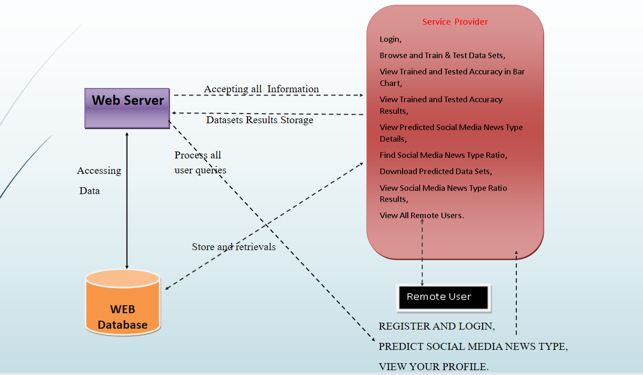

**Figure 4.1 Social Media and Misleading Information in a Democracy A Mechanism Design Approach.**

**4.2 DESCRIPTION**

**Fig. 4.1** shows the block diagram of proposed. Here, data set is considered for evaluating the performance of overall system. Initially, the data set is split-ted into 80% for training and 20% for testing. Then, the entire operations are going to be perform on both training and testing data sets. Further, pre-processing operation is carried out to remove the missing symbols and unknown characters, special characters. The pre-processing operation also normalizes the number of rows and columns presented in the data set. Further, both logical regression, decision tree and random forest algorithm models are applied to evaluate the prediction of data set. So, through this prediction it is going to identify the cardiac arrhythmia presented in overall data set. Finally, performance comparison is takes place between logical regression, decision tree and random forest algorithm.

#### 4.3 USE CASE DIAGRAM

In the use case diagram we have basically two actors who are the user and the stem. Where the user will provide the data in the form of text and system verifies the data in order to give results.The use cases are represented by either circles or ellipses. The actors are often shown as stick figures.

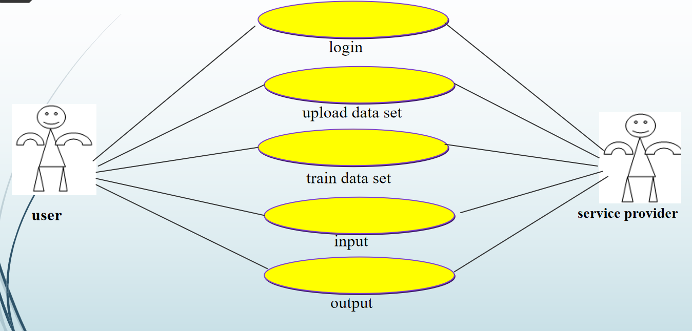

**Figure 4.3: Use Case Diagram for Social Media and Misleading Information in a Democracy A Mechanism Design Approach.**

#### 4.4 CLASS DIAGRAM

Class diagram is the collection of Classes and Objects.It is a type of static structure diagram that describes the structure of a system by showing the system's classes, their attributes, operations(or methods), and the relationships among objects.

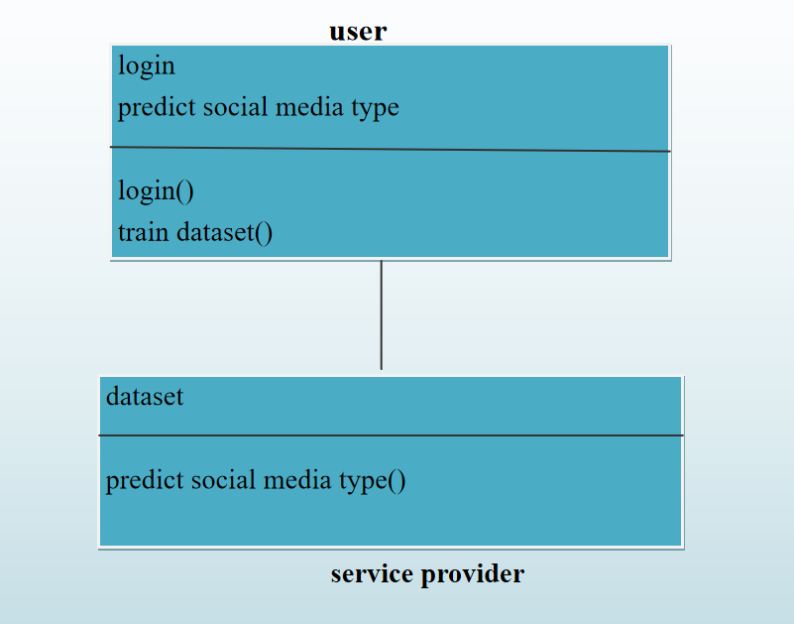

**Figure 4.4: Class Diagram for** **Social Media and Misleading Information in a Democracy A Mechanism Design Approach.**

#### 4.5 SEQUENCE DIAGRAM

Sequence Diagram is an interaction diagram that details how operations are carried out -- what messages are sent and when. Sequence diagrams are organized according to time. The time progresses as you go down the page. The objects involved in the operation are listed from left to right according to when they take part in the message sequence.

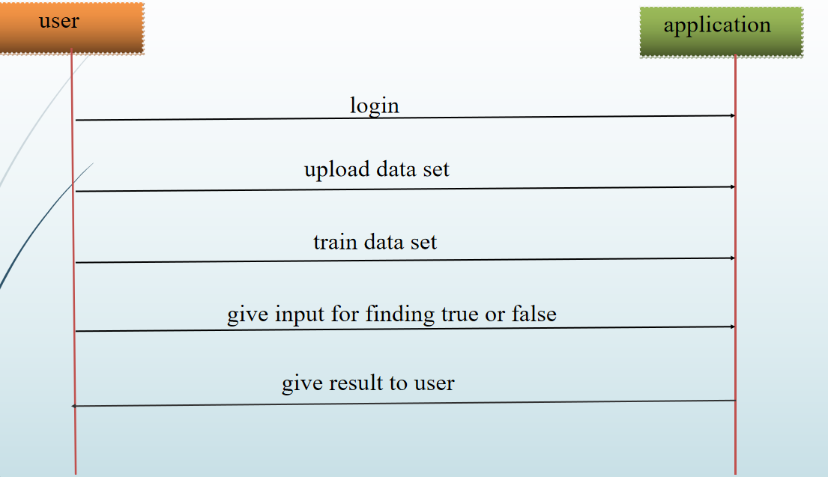

**Figure 4.5: Sequence Diagram for** **Social Media and Misleading Information in a Democracy A Mechanism Design Approach.**

# IMPLEMENTATION

### IMPLEMENTATION

#### 5.1 SAMPLE CODE

import pandas as pd

import numpy as np

import seaborn as sns

import matplotlib.pyplot as plt

from sklearn.model_selection import train_test_split

from sklearn.metrics import accuracy_score

from sklearn.metrics import classification_report

import re

import string

from sklearn.feature_extraction.text import CountVectorizer

from sklearn.metrics import accuracy_score, confusion_matrix, classification_report

from sklearn.ensemble import VotingClassifier

from Remote_User.models import ClientRegister_Model,Social_Media,detection_ratio,detection_accuracy

def serviceproviderlogin(request):

if request.method == "POST":

admin = request.POST.get('username')

password = request.POST.get('password')

if admin == "Admin" and password =="Admin":

return redirect('View_Remote_Users')

return render(request,'SProvider/serviceproviderlogin.html')

def Find_Social_Media_News_Type_Ratio(request):

detection_ratio.objects.all().delete()

ratio = ""

kword = 'Fake'

print(kword)

obj = Social_Media.objects.all().filter(Q(Prediction=kword))

obj1 = Social_Media.objects.all()

count = obj.count();

count1 = obj1.count();

ratio = (count / count1) * 100

if ratio != 0:

detection_ratio.objects.create(names=kword, ratio=ratio)

ratio1 = ""

kword1 = 'True'

print(kword1)

obj1 = Social_Media.objects.all().filter(Q(Prediction=kword1))

obj11 = Social_Media.objects.all()

count1 = obj1.count();

count11 = obj11.count();

ratio1 = (count1 / count11) * 100

if ratio1 != 0:

detection_ratio.objects.create(names=kword1, ratio=ratio1)

    obj = detection_ratio.objects.all()

return render(request, 'SProvider/Find_Social_Media_News_Type_Ratio.html', {'objs': obj})

def View_Remote_Users(request):

obj=ClientRegister_Model.objects.all()

return render(request,'SProvider/View_Remote_Users.html',{'objects':obj})

def ViewTrendings(request):

topic = Social_Media.objects.values('topics').annotate(dcount=Count('topics')).order_by('-dcount')

return render(request,'SProvider/ViewTrendings.html',{'objects':topic})

def charts(request,chart_type):

chart1 = detection_ratio.objects.values('names').annotate(dcount=Avg('ratio'))

return render(request,"SProvider/charts.html", {'form':chart1, 'chart_type':chart_type})

def charts1(request,chart_type):

chart1 = detection_accuracy.objects.values('names').annotate(dcount=Avg('ratio'))

return render(request,"SProvider/charts1.html", {'form':chart1, 'chart_type':chart_type})

def Predict_Social_Media_News_Type(request):

obj =Social_Media.objects.all()

return render(request, 'SProvider/Predict_Social_Media_News_Type.html', {'list_objects': obj})

def likeschart(request,like_chart):

charts =detection_accuracy.objects.values('names').annotate(dcount=Avg('ratio'))

return render(request,"SProvider/likeschart.html", {'form':charts, 'like_chart':like_chart})

def Download_Trained_DataSets(request):

response = HttpResponse(content_type='application/ms-excel')

# decide file name

response['Content-Disposition'] = 'attachment; filename="TrainedData.xls"'

# creating workbook

wb = xlwt.Workbook(encoding='utf-8')

# adding sheet

ws = wb.add_sheet("sheet1")

# Sheet header, first row

row_num = 0

font_style = xlwt.XFStyle()

# headers are bold

font_style.font.bold = True

# writer = csv.writer(response)

obj = Social_Media.objects.all()

data = obj # dummy method to fetch data.

for my_row in data:

row_num = row_num + 1

ws.write(row_num, 0, my_row.News_Data, font_style)

ws.write(row_num, 1, my_row.Prediction, font_style)

wb.save(response)

return response

def Train_Test_DataSets(request):

detection_accuracy.objects.all().delete()

df_fake = pd.read_csv("Fake.csv")

df_true = pd.read_csv("True.csv")

df_fake.head()

df_true.head(5)

df_fake["class"] = 0

df_true["class"] = 1

df_fake.shape, df_true.shape

# Removing last 10 rows for manual testing

df_fake_manual_testing = df_fake.tail(10)

for i in range(23480, 23470, -1):

df_fake.drop([i], axis=0, inplace=True)

df_true_manual_testing = df_true.tail(10)

for i in range(21416, 21406, -1):

df_true.drop([i], axis=0, inplace=True)

df_fake.shape, df_true.shape

df_fake_manual_testing["class"] = 0

df_true_manual_testing["class"] = 1

df_fake_manual_testing.head(10)

df_true_manual_testing.head(10)

df_manual_testing = pd.concat([df_fake_manual_testing, df_true_manual_testing], axis=0)

df_manual_testing.to_csv("manual_testing.csv")

df_merge = pd.concat([df_fake, df_true], axis=0)

df_merge.head(10)

df_merge.columns

df = df_merge.drop(["title", "subject", "date"], axis=1)

df.isnull().sum()

df = df.sample(frac=1)

df.head()

df.reset_index(inplace=True)

df.drop(["index"], axis=1, inplace=True)

df.columns

df.head()

def wordopt(text):

text = text.lower()

text = re.sub('\[.*?\]', '', text)

text = re.sub("\\W", " ", text)

text = re.sub('https?://\S+|www\.\S+', '', text)

text = re.sub('<.*?>+', '', text)

text = re.sub('[%s]' % re.escape(string.punctuation), '', text)

text = re.sub('\n', '', text)

text = re.sub('\w*\d\w*', '', text)

return text

cv = CountVectorizer()

df["text"] = df["text"].apply(wordopt)

x = df["text"]

y = df["class"]

x = cv.fit_transform(x)

x_train, x_test, y_train, y_test = train_test_split(x, y, test_size=0.25)

from sklearn.linear_model import LogisticRegression

print("Logistic Regression")

LR = LogisticRegression()

LR.fit(x_train, y_train)

pred_lr = LR.predict(x_test)

LR.score(x_test, y_test)

print("ACCURACY")

print(accuracy_score(y_test, pred_lr) * 100)

print("CLASSIFICATION REPORT")

print(classification_report(y_test, pred_lr))

print("CONFUSION MATRIX")

print(confusion_matrix(y_test, pred_lr))

detection_accuracy.objects.create(names="Logistic Regression", ratio=accuracy_score(y_test, pred_lr) * 100)

print("Decision Tree Classifier")

from sklearn.tree import DecisionTreeClassifier

DT = DecisionTreeClassifier()

DT.fit(x_train, y_train)

pred_dt = DT.predict(x_test)

DT.score(x_test, y_test)

print("ACCURACY")

print(accuracy_score(y_test, pred_dt) * 100)

print("CLASSIFICATION REPORT")

print(classification_report(y_test, pred_dt))

print("CONFUSION MATRIX")

print(confusion_matrix(y_test, pred_dt))

detection_accuracy.objects.create(names="Decision Tree Classifier", ratio=accuracy_score(y_test, pred_dt) * 100)

print("Random Forest Classifier")

from sklearn.ensemble import RandomForestClassifier

RFC = RandomForestClassifier(random_state=0)

RFC.fit(x_train, y_train)

pred_rfc = RFC.predict(x_test)

RFC.score(x_test, y_test)

print("ACCURACY")

print(accuracy_score(y_test, pred_rfc) * 100)

print("CLASSIFICATION REPORT")

print(classification_report(y_test, pred_rfc))

print("CONFUSION MATRIX")

print(confusion_matrix(y_test, pred_rfc))

detection_accuracy.objects.create(names="Random Forest Classifier", ratio=accuracy_score(y_test, pred_rfc) * 100)

obj = detection_accuracy.objects.all()

return render(request,'SProvider/Train_Test_DataSets.html', {'objs': obj})

# RESULTS

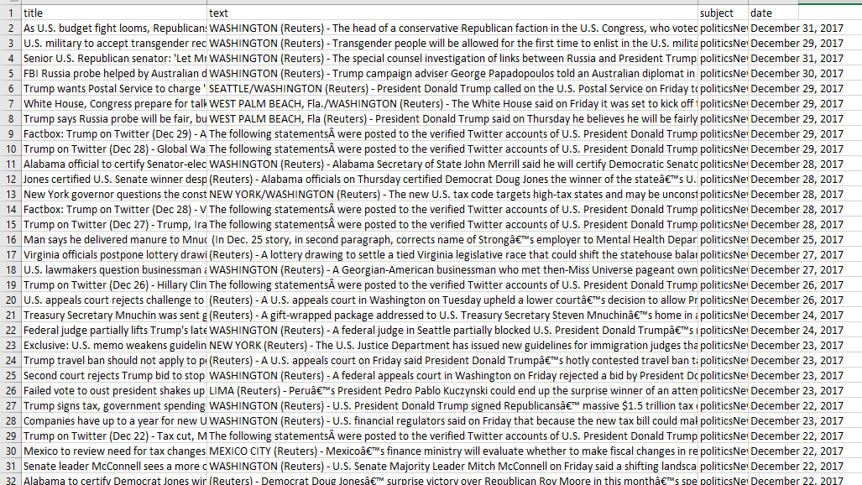

**Fig 6.1 To train both algorithm we have used above True data set**

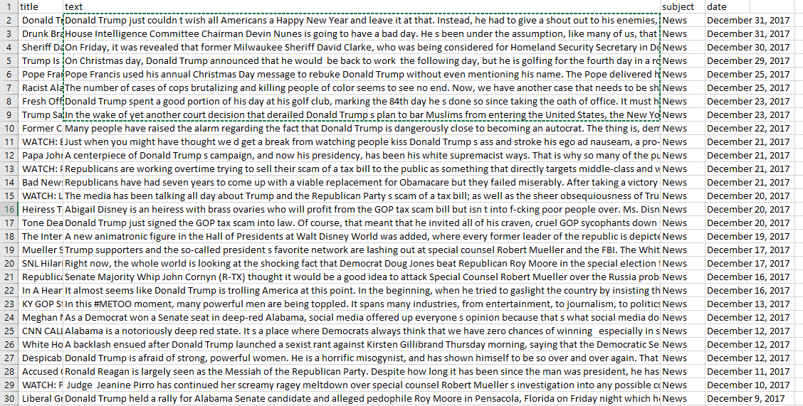

**Fig 6.2. To train both algorithm we have used above True data set**

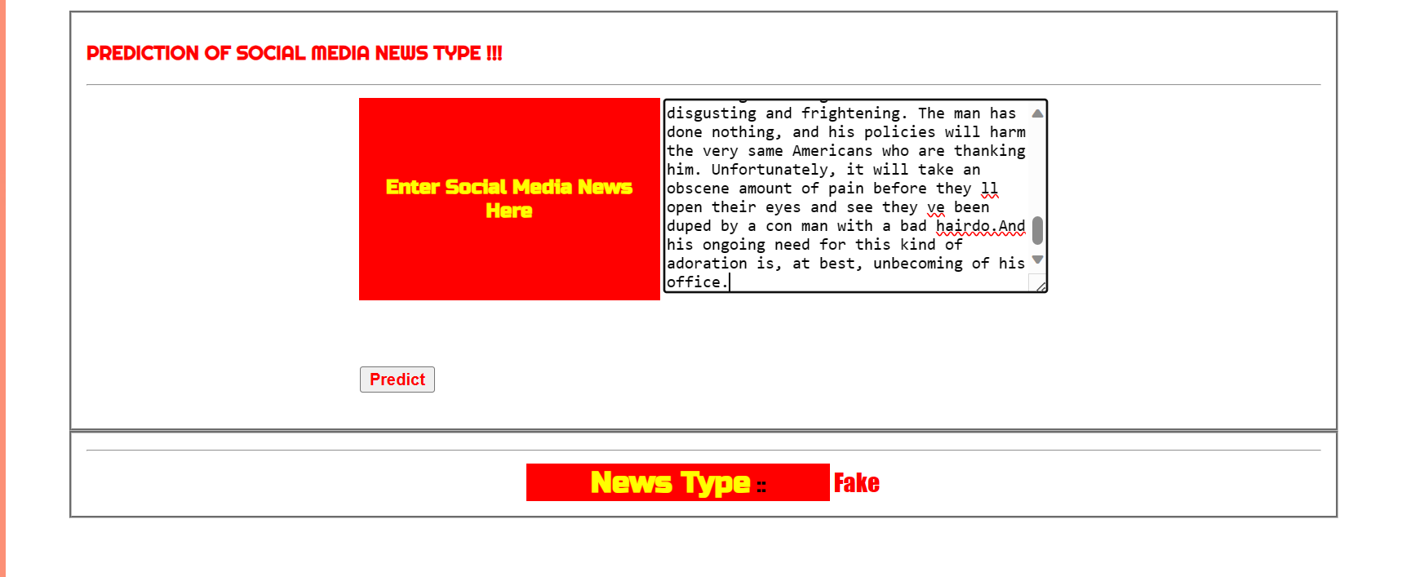

**Fig 6.3. Testing the news type for False Data Set**

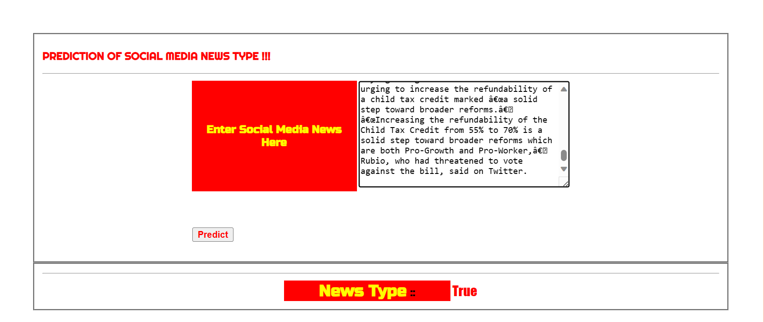

**Fig 6.4. Testing the news type for False Data Set**

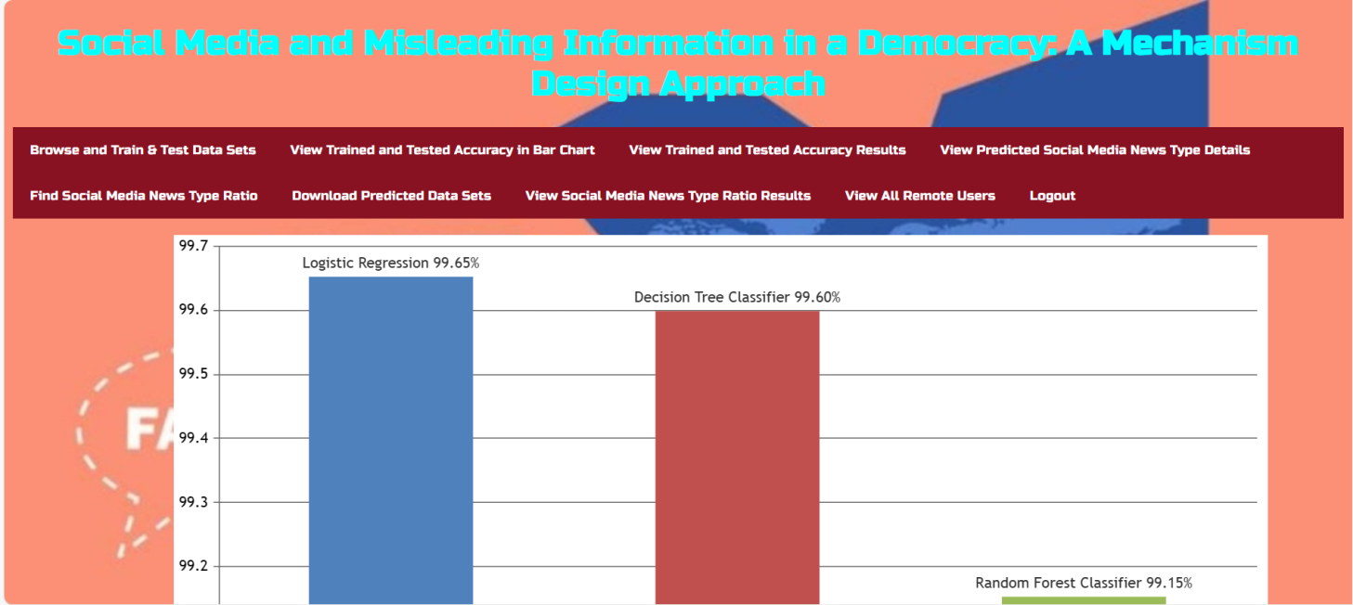

**Fig 6.5.Bar Graph for comparison of algorithms accuracy**

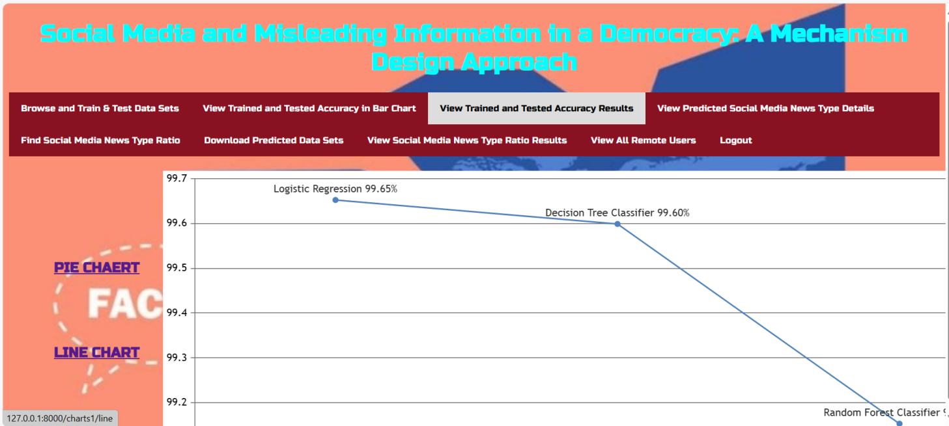

**Fig 6.6. .Line Graph for comparison of algorithms accuracy**

**7.TESTING**

# 7. TESTING

## 7.1 INTRODUCTION TO TESTING

The purpose of testing is to discover errors. Testing is the process of trying to discover every conceivable fault or weakness in a work product. It provides a way to check the functionality of components, subassemblies, assemblies and/or a finished product. It is the process of exercising software with the intent of ensuring that the Software system meets its requirements and user expectations and does not fail in an unacceptable manner. There are various types of tests. Each test type addresses a specific testing requirement.

## 7.1.1 SOFTWARE TESTING

Software testing is one of the main stages of project development life cycle to provide our cessation utilizer with information about the quality of the application and ours, in our Project we have under gone some stages of testing like unit testing where it’s done in development stage of the project when we are in implementation of the application after the Project is yare we have done manual testing with different Case of all the different modules in the application we have even done browser compatibility testing in different web browsers in market, even we have done Client side validation testing on our application

## 7.2 TYPES OF TESTING

**7.2.1 Unit testing**

Unit testing involves the design of test cases that validate that the internal program logic is functioning properly, and that program inputs produce valid outputs. All decision branches and internal code flow should be validated. It is the testing of individual software units of the application .it is done after the completion of an individual unit before integration. This is a structural testing, that relies on knowledge of its construction and is invasive. Unit tests perform basic tests at component level and test a specific business process, application, and/or system configuration. Unit tests ensure that each unique path of a business process performs accurately to the documented specifications and contains clearly defined inputs and expected results.

**7.2.2 Integration testing**

Integration tests are designed to test integrated software components to determine if they actually run as one program. Testing is event driven and is more concerned with the basic outcome of screens or fields. Integration tests demonstrate that although the components were individually satisfaction, as shown by successfully unit testing, the combination of components is correct and consistent. Integration testing is specifically aimed at exposing the problems that arise from the combination of components.

**7.2.3 Functional test**

Functional tests provide systematic demonstrations that functions tested are available as specified by the business and technical requirements, system documentation, and user manuals.

Functional testing is centered on the following items:

Valid Input : identified classes of valid input must be accepted.

Invalid Input : identified classes of invalid input must be rejected.

Functions : identified functions must be exercised.

Output : identified classes of application outputs must be exercised.

Systems/Procedures : interfacing systems or procedures must be invoked.

Organization and preparation of functional tests is focused on requirements, key functions, or special test cases. In addition, systematic coverage pertaining to identify Business process flows; data fields, predefined processes, and successive processes must be considered for testing. Before functional testing is complete, additional tests are identified and the effective value of current tests is determined.

**8.CONCLUSION**

#### 8.CONCLUSION & FUTURE SCOPE

#### PROJECT CONCLUSION

Our primary goal in this project was to design a mechanism to induce a GNE solution in the misinformation filtering game, where (i) each platform agrees to participate voluntarily, and (ii) the collective utility of the government and the platforms is maximized. We designed a mechanism and proved that it satisfies these properties along with budget balance. We also presented an extension of the mechanism with weaker technical assumptions.

In this it focuses on improving the valuation and average trust functions of the social media platforms based on data. We also consider incorporating uncertainty in a platform’s estimates of the impact of their filter. These refinements of the modeling framework will allow us to make our mechanism more practical for use in the real world.

#### 

#### 8.2 FUTURE SCOPE

Though deep learning networks produces excellent results, the disadvantage lies in the insufficient understanding of the complex inner mechanisms of the deep learning networks. This could be overcome by remodelling the nonlinear deep networks to a linear form by computing eigenvalues and eigenvectors in different time steps. The future work can be the collection of real-world datasets from hospitals having cardiac care units and the application of the same methodologies to the real datasets.

# 9. BIBLIOGRAPHY

# 9. BIBLIOGRAPHY

#### 9.1 REFERENCES

[1] W. Davies, “The age of post-truth politics,” *The New York Times*, vol. 24,

p. 2016, 2016.

[2] J. Cone, K. Flaharty, and M. J. Ferguson, “Believability of evidence

matters for correcting social impressions,” *Proceedings of the National*

*Academy of Sciences*, vol. 116, no. 20, pp. 9802–9807, 2019.

[3] Z. Tufekci, “Youtube, the great radicalizer,” *The New York Times*, vol. 10,

2018.

[4] A. D. Kramer, J. E. Guillory, and J. T. Hancock, “Experimental evidence

of massive-scale emotional contagion through social networks,”

*Proceedings of the National Academy of Sciences*, vol. 111, no. 24, pp.

8788–8790, 2014.

[5] J. Weedon, W. Nuland, and A. Stamos, “Information operations

and facebook,” *Retrieved from: https://fbnewsroomus. files. wordpress.*

*com/2017/04/facebook-and-information-operations-v1. pdf*, 2017.

[6] H. Farrell and B. Schneier, “Common-knowledge attacks on democracy,”

*Berkman Klein Center Research Publication*, no. 2018-7, 2018.

[7] H. Allcott and M. Gentzkow, “Social media and fake news in the 2016

election,” *Journal of economic perspectives*, vol. 31, no. 2, pp. 211–36,

2017.

[8] O. Analytica, “Russia will deny cyberattacks despite more us evidence,”

*Emerald Expert Briefings*, no. oxan-db, 2018.

[9] A. Bessi, M. Coletto, G. A. Davidescu, A. Scala, G. Caldarelli, and

W. Quattrociocchi, “Science vs conspiracy: Collective narratives in the

age of misinformation,” *PloS one*, vol. 10, no. 2, p. e0118093, 2015.

[10] E. Brown, “Propaganda, misinformation, and the epistemic value of

democracy,” *Critical Review*, vol. 30(3–4), pp. 194–218, 2018.

[11] J. A. Tucker, Y. Theocharis, M. E. Roberts, and P. Barber´a, “From liberation

to turmoil: Social media and democracy,” *Journal of Democracy*,

vol. 28(4), pp. 46–59, 2017.

[12] A. Sternisko, A. Cichocka, and J. J. Van Bavel, “The dark side of social

movements: Social identity, non-conformity, and the lure of conspiracy

theories,” *Current opinion in psychology*, vol. 35, pp. 1–6, 2020.

[13] R. Jaakonm¨aki, O. M¨uller, and J. Vom Brocke, “The impact of content,

context, and creator on user engagement in social media marketing,”

*Proceedings of the 50th Hawaii international conference on system*

*sciences*, 2017.

[14] O. Candogan and K. Drakopoulos, “Optimal signaling of content accuracy:

Engagement vs. misinformation,” *Operations Research*, vol. 68,

no. 2, pp. 497–515, 2020.

[15] E. A. Vogels, A. Perrin, and M. Anderson. (2020) Most americans

think social media sites censor political viewpoints. [Online]. Available:

https://www.pewresearch.org/internet/2020/08/19/most-americans-think-social-media-sites-[16] S. Vosoughi, D. Roy, and S. Aral, “The spread of true and false news

online,” *Science*, vol. 359, no. 6380, pp. 1146–1151, 2018.

[17] A. Mas-Colell, M. D. Whinston, and J. R. Green, *Microeconomic theory*.

Oxford University Press, 1995.

[18] A. Dave and A. Malikopoulos, “The prescription approach to decentralized

stochastic control with word-of-mouth communication,” *arXiv*

*e-prints*, p. arXiv:1907.12125, Sep 2019.

[19] A. Mahajan, N. C. Martins, M. C. Rotkowitz, and S. Y¨uksel, “Information

structures in optimal decentralized control,” in *2012 IEEE 51st*

*IEEE Conference on Decision and Control (CDC)*. IEEE, 2012, pp.

1291–1306.

[20] A. Nayyar, A. Mahajan, and D. Teneketzis, “Decentralized stochastic

control with partial history sharing: A common information approach,”

*IEEE Transactions on Automatic Control*, vol. 58, no. 7, pp. 1644–1658,

2013.

[21] A. A. Malikopoulos, C. G. Cassandras, and Y. J. Zhang, “A decentralized

energy-optimal control framework for connected automated vehicles at

signal-free intersections,” *Automatica*, vol. 93, no. April, pp. 244–256,

2018.

[22] S. Sharma and D. Teneketzis, “Local public good provisioning in networks:

A Nash implementation mechanism,” *IEEE Journal on Selected*

*Areas in Communications*, vol. 30, no. 11, pp. 2105–2116, 2012.

[23] A. Sinha and A. Anastasopoulos, “Generalized proportional allocation

mechanism design for multi-rate multicast service on the internet,”

*51st Annual Allerton Conference on Communication, Control, and*

*Computing (Allerton)*, pp. 146–153, 2013.

[24] A. Kakhbod and D. Teneketzis, “An efficient game form for unicast

service provisioning,” *IEEE Transactions on Automatic Control*, vol. 57,

no. 2, pp. 392–404, 2011.

[25] R. Jain and J. Walrand, “An efficient nash-implementation mechanism

for network resource allocation,” *Automatica*, vol. 46(8), pp. 1276–1283,

2010.

**9.2 GITHUB LINK**

LINK:[https://github.com/207R1A05D5/AUTOMATED-DETECTION-OF-CARDIAC-ARRHYTHMIA-USING-RECURRENT-NEURAL-NETWORK-](https://github.com/KarthikBogelly/Minor_Project.git)